Date of Submission: **10/7/2024**

Name: Mounika Rayapudi

Institute: SRM Institute of Science and Technology Kattankulathur

Branch/Specialization: (Integrated) M. Tech - Artificial Intelligence [Dept: Computational Intelligence]

Register Number: RA2312701010014

Internal Mentor: Dr. Sumathy G.

External Mentor: Dr. Vasudha Kumari (AI Software Solutions Engineer, Intel)

**Customized AI Kitchen for India**

# In Intel’s Industrial Training Program, the problem statement assigned to me was Customized AI kitchen for India statement. It represents the next evolution in culinary technology, bringing personalization and efficiency to home and professional kitchens alike. This innovative approach leverages artificial intelligence to tailor kitchen experiences to individual preferences and needs, enhancing the cooking process in several key areas. This project is developed in python programming language, a powerful programming platform and uses a chatbot to increase the reliability, readability and comfort for the user.

### **Key Features:**

1. **Greeting and Farewell:**
   * Randomized greetings and farewells provide a friendly user interaction.
2. **Ingredient Management:**
   * Checking if the necessary ingredients are available for a dish.
   * Preparing a dish by deducting the required ingredients.
   * Adding ingredients to the kitchen inventory.
   * Listing all current ingredients in the kitchen.
3. **Menu Checking:**
   * Displaying available dishes.
4. **User Interaction:**
   * Interpreting user commands to perform the corresponding kitchen operations.

The code is as follows:

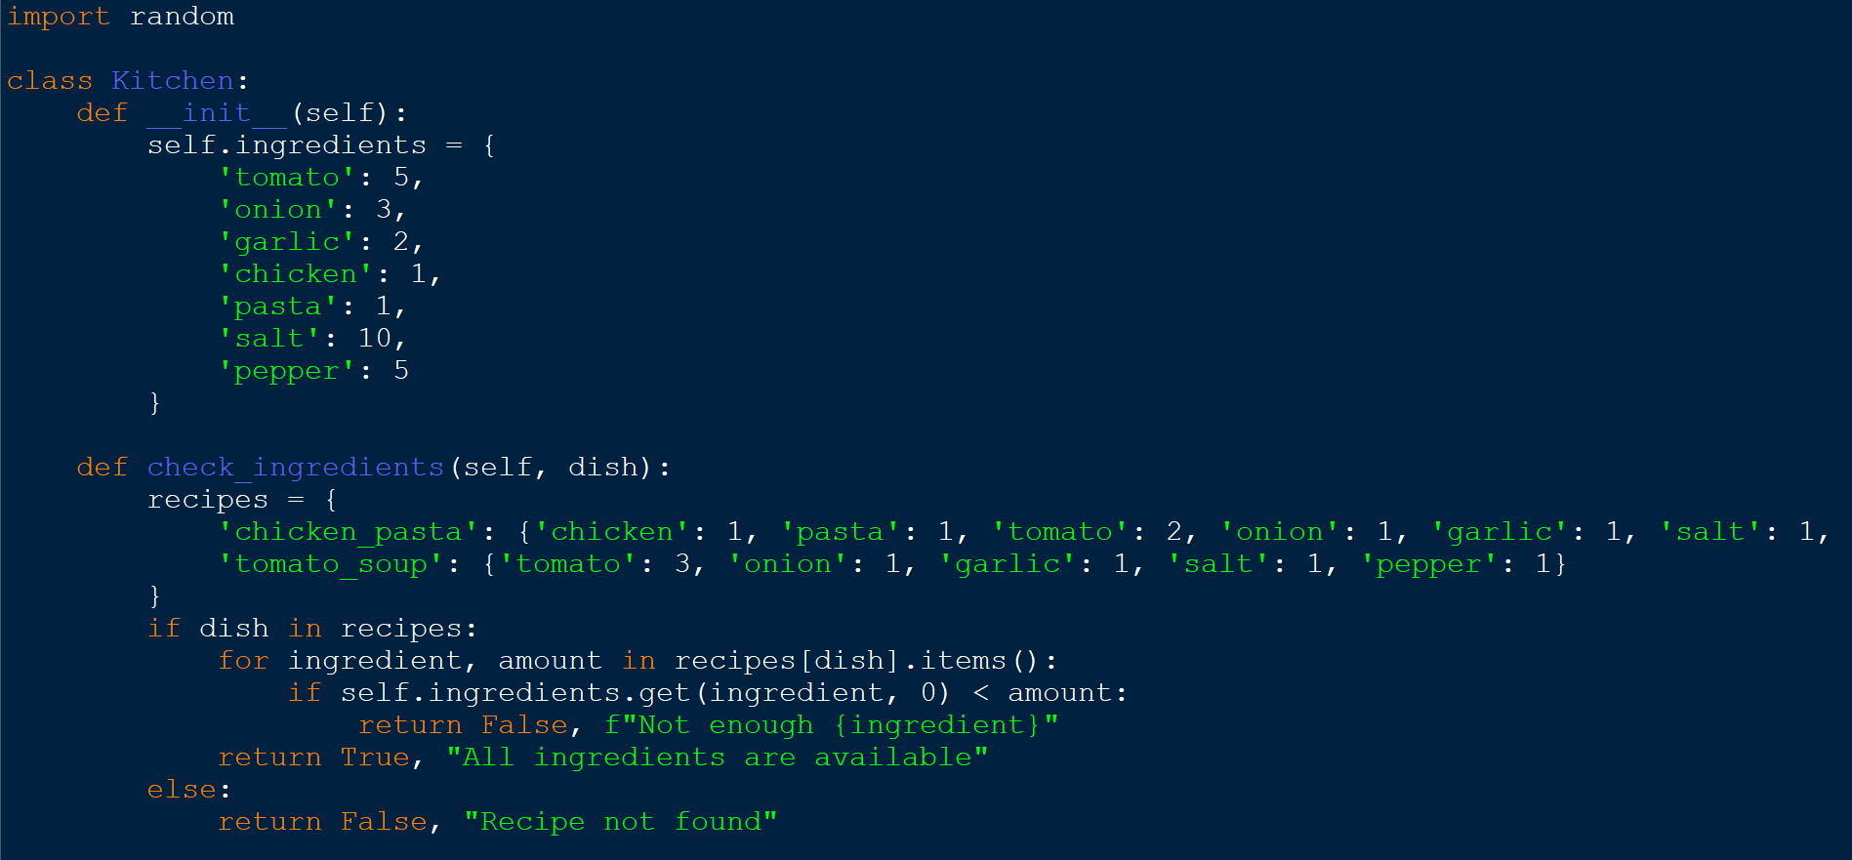

Here we import the random module which will be used later for selecting random greetings and farewells in the ChatBot class. The Kitchen class, which will manage the kitchen's ingredients and handle recipe checks.

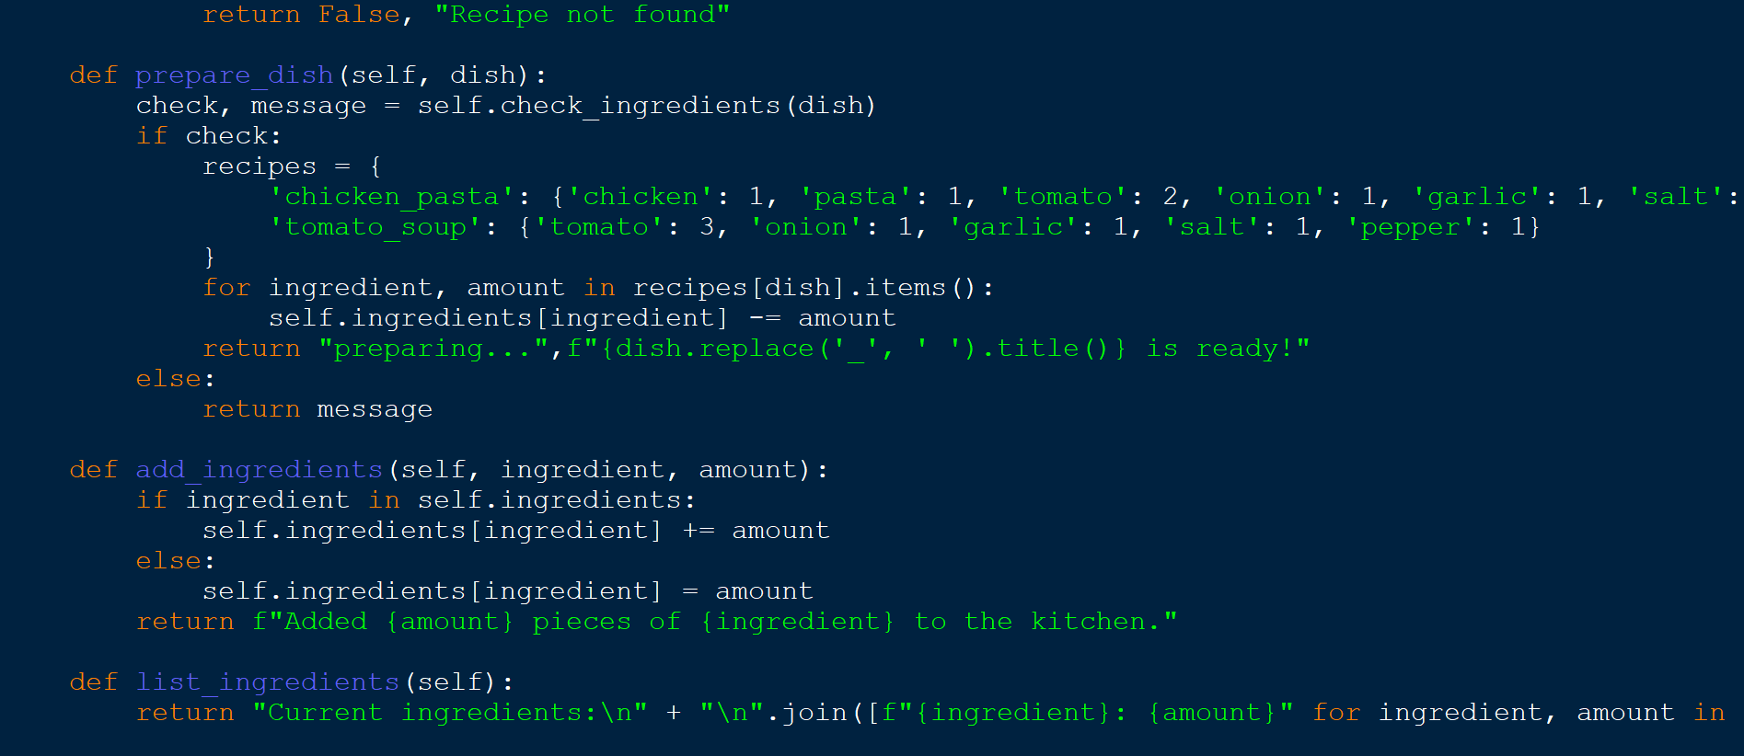

The prepare_dish method takes dish as an argument. This method attempts to prepare the specified dish by checking and using the necessary ingredients. The check_ingredients method to determine if all required ingredients for the specified dish are available. the add_ingredients method, which takes ingredient and amount as arguments. This method adds the specified amount of the given ingredient to the kitchen's inventory.

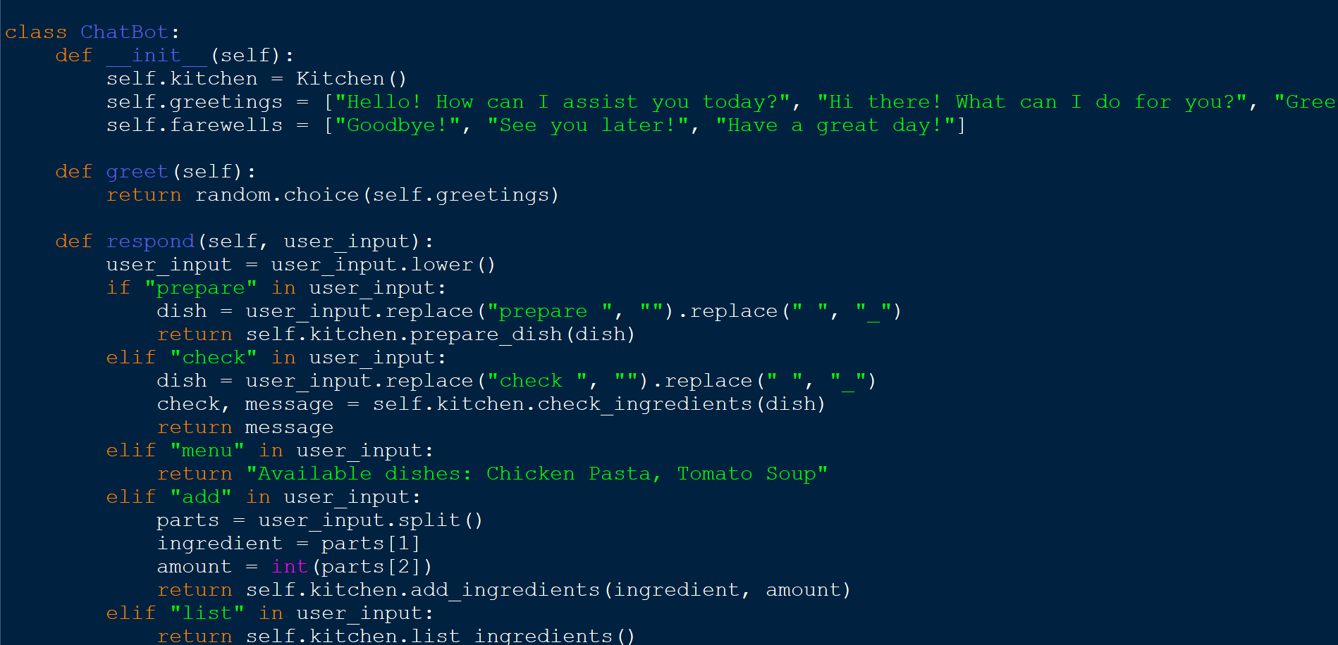

The ChatBot class is a blueprint for creating objects (instances), and in this case, it is designed to interact with the user and manage the kitchen's functionalities. The random.choice(self.greetings) selects a random greeting from the list of greetings, providing a varied and friendly interaction with the user each time the method is called. The respond method processes the user's input and performs corresponding actions based on the commands detected in the input.

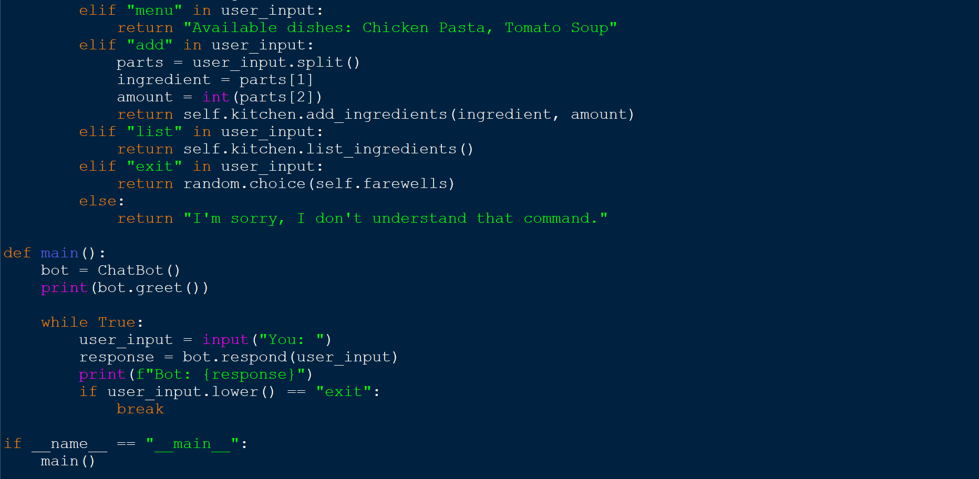

The main function is the entry point for running the chatbot.

Initiation of an infinite loop to continually interact with the user until the user decides to exit.

If the user input is "exit", the loop breaks, ending the interaction.

**Conclusion**

The provided code represents a interactive chatbot application designed to manage a kitchen inventory and prepare dishes based on user commands.

The code effectively demonstrates how a simple chatbot can manage kitchen operations by leveraging classes and methods to perform specific tasks. The Kitchen class encapsulates the core functionality related to ingredient management, while the ChatBot class provides a user-friendly interface for interacting with the kitchen.

The chatbot's ability to respond to various commands, provide real-time feedback, and manage the kitchen inventory showcases a practical application of object-oriented programming concepts in Python.

What I have learnt is:

* Object-Oriented Programming (OOP) Principles
* Handling User Input and Commands
* Managing State and Data
* Interactive design and practical application
* Testing and Evaluation

Reflections:

Overall, participating in Intel's Industrial Training Program was an invaluable experience. It provided practical skills, industry insights, and the opportunity to work on cutting-edge technology. The project not only enhanced my understanding of AI and deep level of programming but also equipped me with the knowledge to tackle real-world challenges in the tech industry. Intel's Industrial Training Program offers a unique blend of theoretical knowledge and practical experience, preparing students for careers in technology. The skills and knowledge gained through this experience will undoubtedly be beneficial in my future endeavors in the field of technology.

***THANK YOU***